Model summaries and evaluation of fit
Draft version 11-06-2018

1 Verb-adverb placement
Newspapers

Fixed effects:
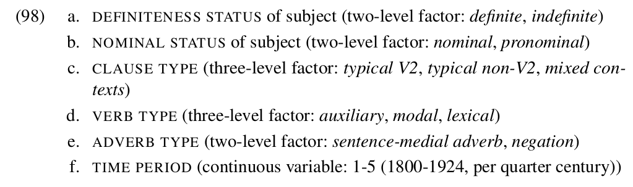

Models outputs (testing of different models)

lme4:
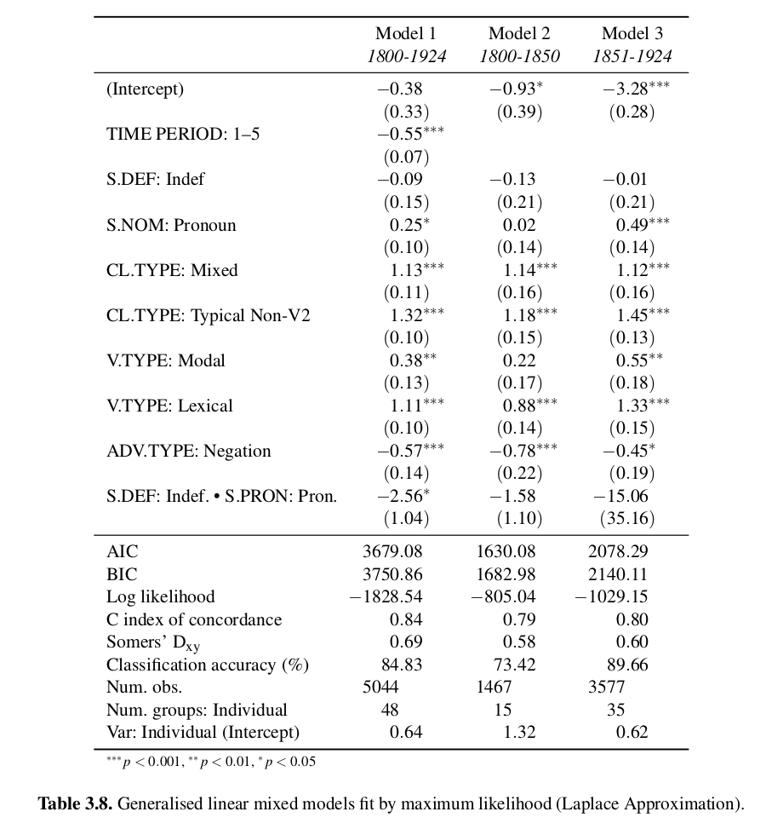

LanguageR plot:
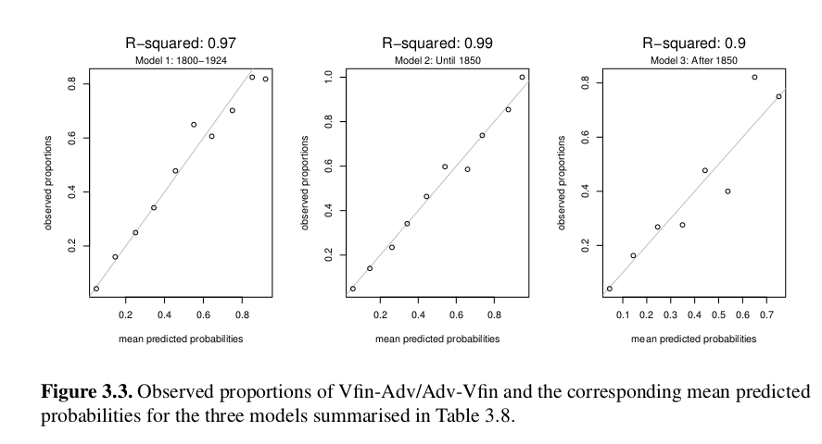

1 Verb-adverb placement
Student essays
Verb-adverb placement

Fixed effects:
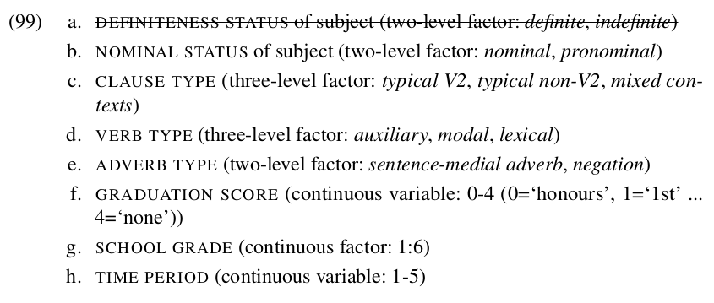

Models outputs (testing of different models)

lme4:
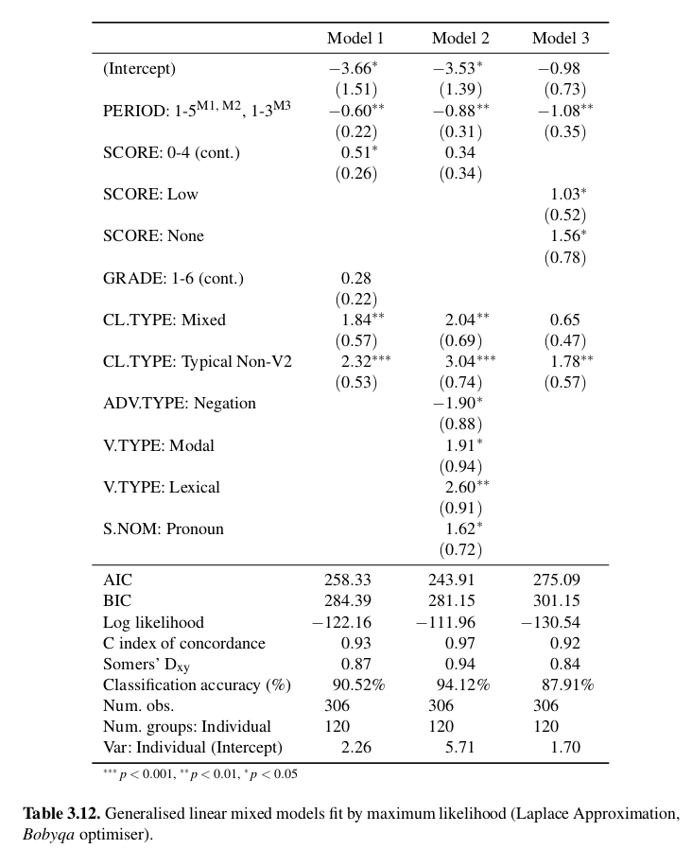

LanguageR plot:
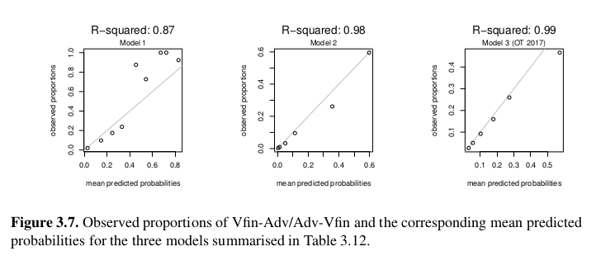

1 Verb-adverb placement
Private letters

Fixed effects:
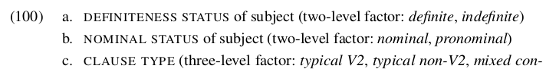
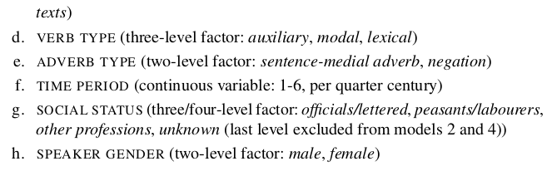

Models outputs (testing of different models)

lme4:
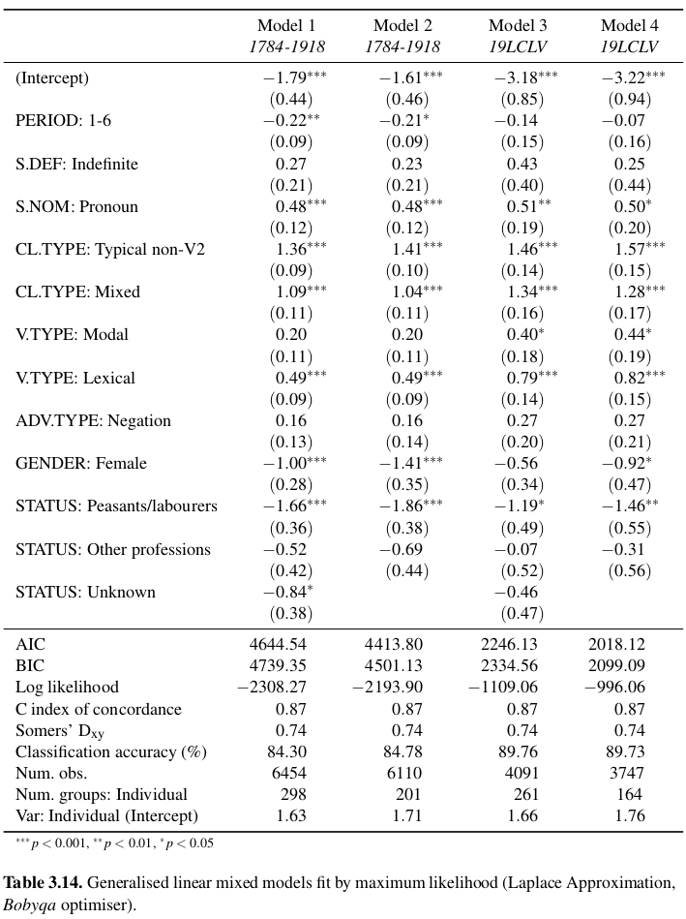

LanguageR plot:
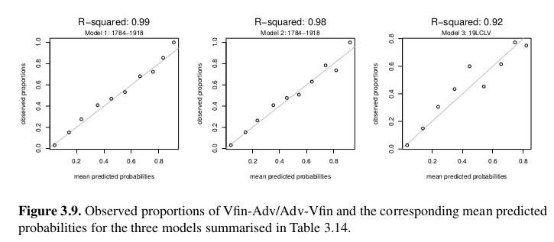

Region
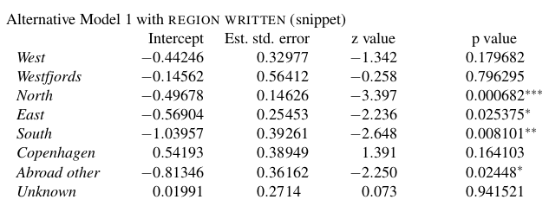

2 Definite article
Newspapers

Fixed effects:
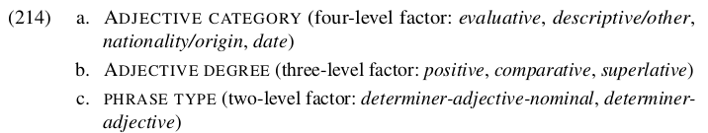

Models outputs (testing of different models)

lme4:
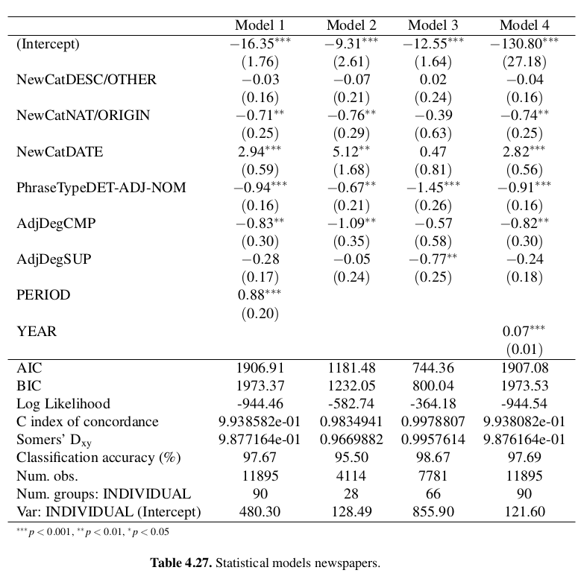

LanguageR plot:
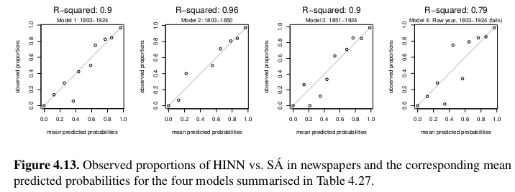

2 Definite article
Private letters

Fixed effects:
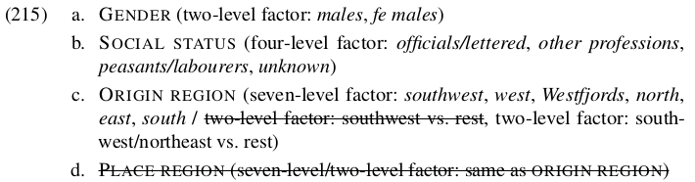

Models outputs (testing of different models)

lme4:
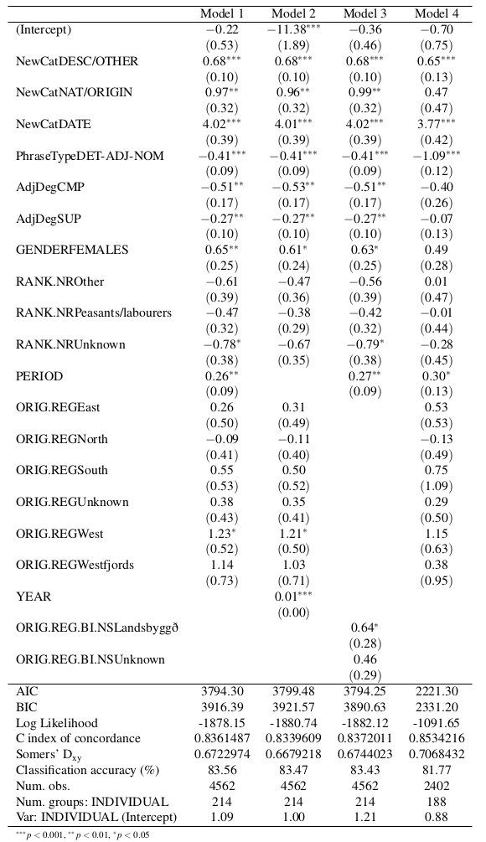

LanguageR plot:
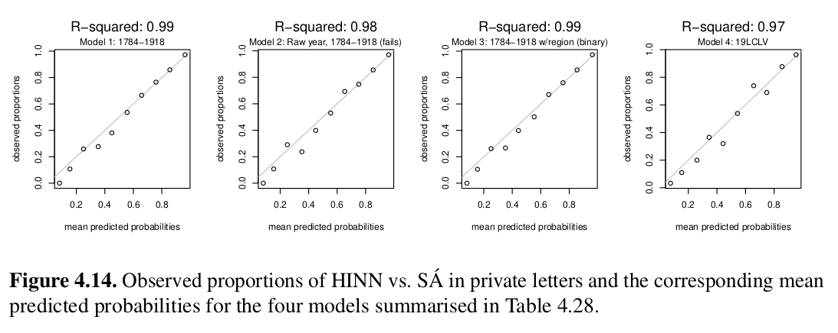

2 Definite article
Student essays

Fixed effects:
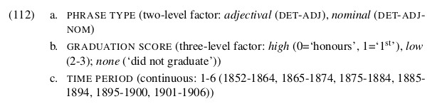

Model output

lme4:
HFV – Orð og tunga 2017 paper. For the differences, see dissertation (section 4.3.4).

